[](http://www.medisense.org.uk/image/commandment/uploads/enjoy-the-job-55e6088f1630a.jpg) [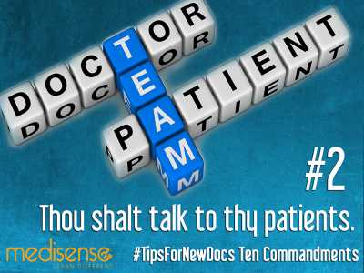](http://www.medisense.org.uk/image/commandment/uploads/talk-to-thy-patients-55e609621e975.jpg)

[](http://www.medisense.org.uk/image/commandment/uploads/honor-thy-nurses-55e608d32603c.jpg) [](http://www.medisense.org.uk/image/commandment/uploads/make-sure-thy-tests-are-necess-55e608fcac11a.jpg)

[](http://www.medisense.org.uk/image/commandment/uploads/annual-leave-55e6086b14fe6.jpg) [](http://www.medisense.org.uk/image/commandment/uploads/eportfolio-55e608b10aa3c.jpg)

[](http://www.medisense.org.uk/image/commandment/uploads/thou-shalt-write-ledibly-55e609f44b51a.jpg) [](http://www.medisense.org.uk/image/commandment/uploads/scan-requests-55e6091ae4ca1.jpg)

[](http://www.medisense.org.uk/image/commandment/uploads/the-list-55e6099261cee.jpg) [](http://www.medisense.org.uk/image/commandment/uploads/think-about-fluids-55e609c64a2f1.jpg)

<https://www.medisense.org.uk/read/tips-for-new-doctors/>

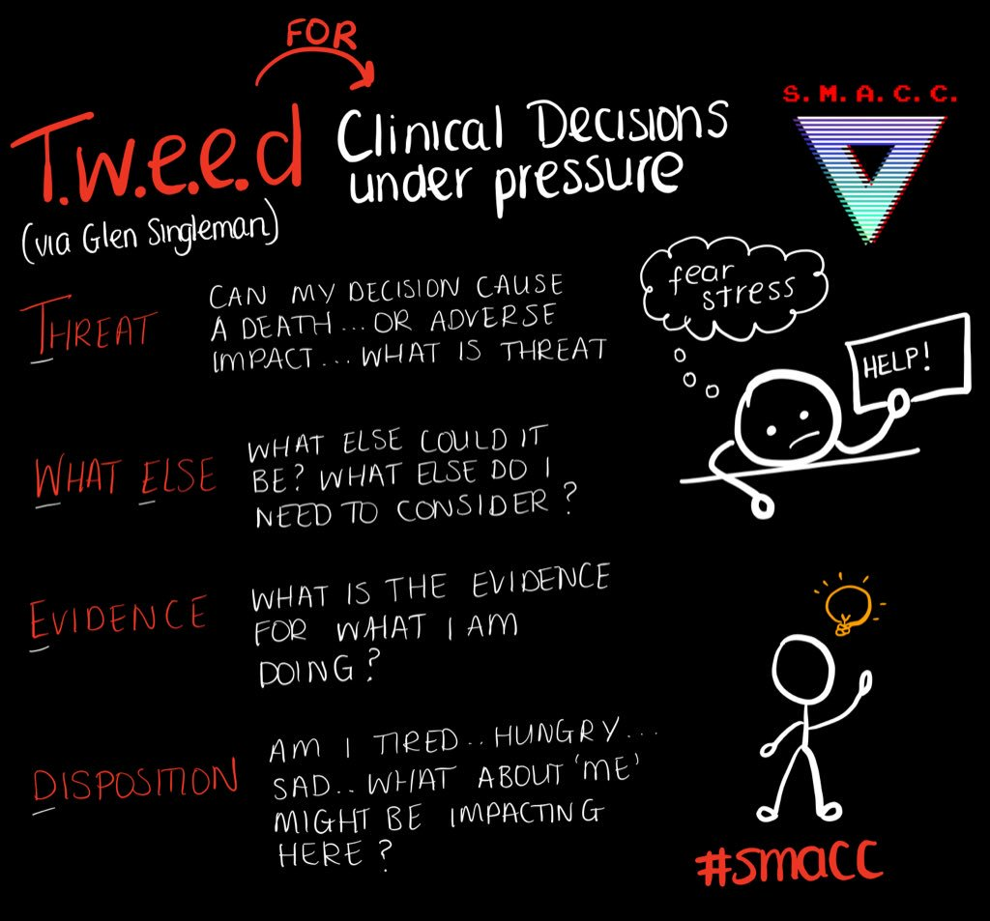

<https://twitter.com/whistlingdixie4/status/1111038839357759488>

<https://www.twipu.com/Fy1Buddy/tweet/1159463980781461506>

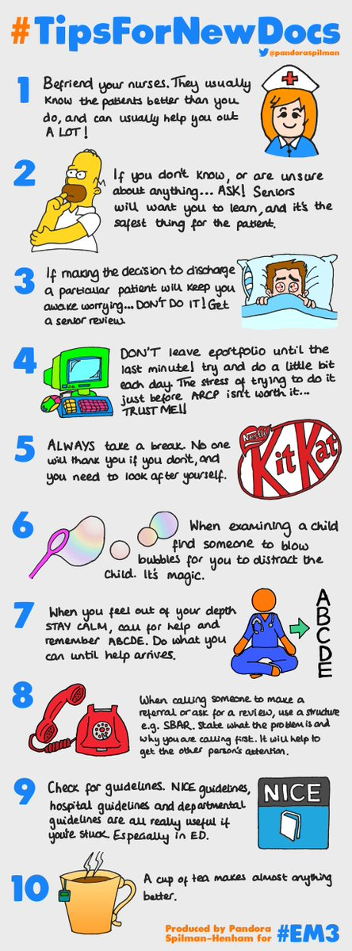

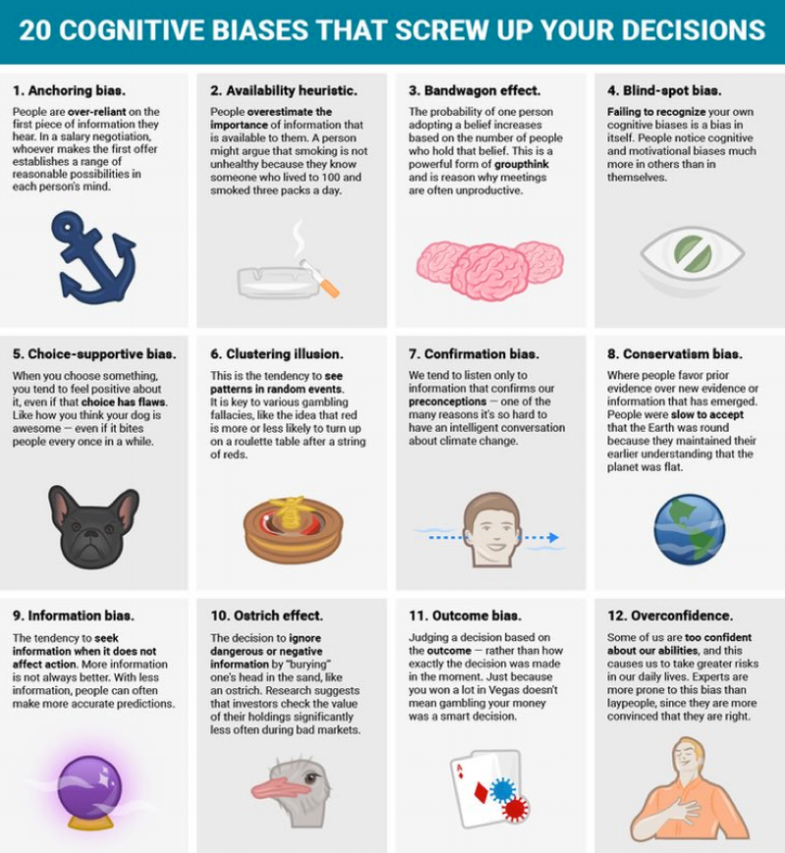

https://stmungos-ed.com/blog/10tipsnewdocs

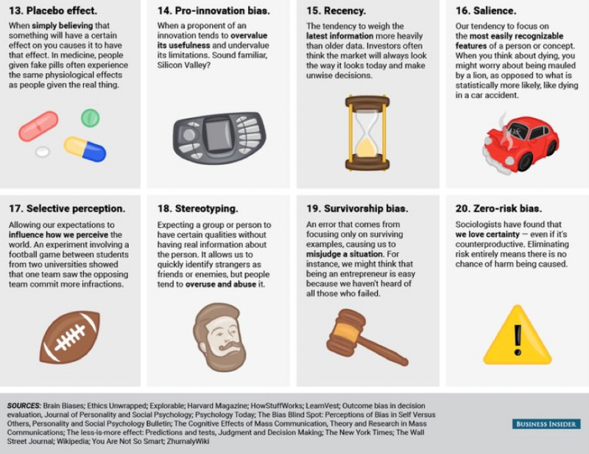

<https://blog.mymedutopia.com/index.php/2018/07/31/amal-mattus-top-10-list-for-interns/>

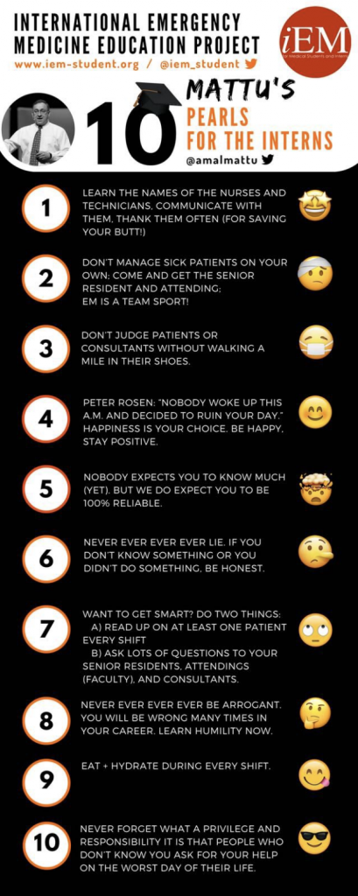

<https://brokentoydotblog.wordpress.com/home/shared-meded-resources/> 