Please note that certain areas/cubicles are set aside for specific patients:
Departmental Map (not to scale) COVID-19 Era

Workstation

Goldfish Bowl 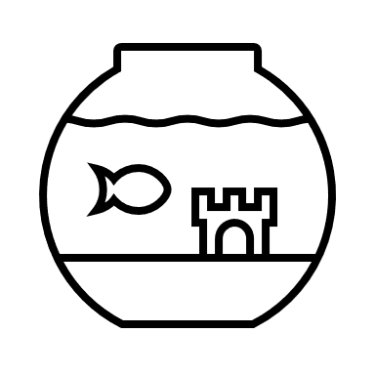

Cubicle 4

Cubicle 5

Cubicle 6

Fit to Sit Area

RRAA 10

RRAA 11

POC Test

RRAA
8

RRAA
7

RRAA 12
Triage

Plaster Room 1

Plaster Room 2

Plaster Room 3

Ambulance Entrance

Resus 3

Resus 2

Resus 1
Paeds
Resus 4

Viewing Room
Deceased
Family Room

Clinic Room 2
Mental Health
Triage 2/ REACT

Waiting Room
Back Store
Eye Room
Sluice 2
RRAA 6

RRAA 4

RRAA 5

Assessment 1
Cubicle 1
COVID Resus
Cubicle 2

Assessment 2
Assessment 3
Cubicle 3

Consultant Offices
Break/Changing Rooms
Seminar Room
Major Incident Store

COVID ABG
Clean Prep/ Clean ABG/
Drug Cupboards
Minors 4 & 5
Minors Workstation
WC

Triage 1

Reception

RRAA Workstation

RRAA 1

RRAA 2

RRAA 3

Minors 1
Cubicle 12
COVID
Cubicle 11
COVID/Dementia
Cubicle 10
COVID
Cubicle 9

Cubicle 8

Cubicle 7

Charge Nurse/Child Protection/Navigators
Minors 2
Minors 3
Back Store
Exit/
X-ray/
Patient WC
Resus Store
Sluice 1

